Abugida Writing system

What is Abugida Writing system
# Source: AI Source: Provided by: [Data Path: Persons Table -> ID Column: 1, Name_En Column: Motasem Essam] -> From: [Chatgpt (GPT-4-turbo)] on [7/21/2025]
An abugida is a type of writing system where each symbol represents a consonant with an inherent vowel, and other vowels are indicated by modifying the base symbol, usually with diacritical marks or slight changes to the shape.

What Is a Consonant with an Inherent Vowel?
# Source: AI Source: Provided by: [Data Path: Persons Table -> ID Column: 1, Name_En Column: Motasem Essam] -> From: [Chatgpt (GPT-4-turbo)] on [7/21/2025]
Great question! Let’s break down what "consonant with an inherent vowel" means in the context of abugida writing systems.

🔤 What Is a Consonant with an Inherent Vowel?
# Source: AI Source: Provided by: [Data Path: Persons Table -> ID Column: 1, Name_En Column: Motasem Essam] -> From: [Chatgpt (GPT-4-turbo)] on [7/21/2025]
In an abugida, every consonant letter automatically includes a default vowel sound, even if that vowel isn’t written separately.
This default vowel is called the inherent vowel.

✅ Example (from Hindi/Devanagari):
# Source: AI Source: Provided by: [Data Path: Persons Table -> ID Column: 1, Name_En Column: Motasem Essam] -> From: [Chatgpt (GPT-4-turbo)] on [7/21/2025]
Take the Devanagari character:
- क → Pronounced "ka"
  - Here, "क" is not just "k" — it automatically includes the vowel "a".
If you want a different vowel sound, you modify the symbol:
- कि → "ki" (with vowel mark for "i")
- के → "ke" (with vowel mark for "e")
- क् → "k" (no vowel — the vowel is removed using a special mark called a virama or halant)

🧠 Analogy (Compared to an Alphabet):
# Source: AI Source: Provided by: [Data Path: Persons Table -> ID Column: 1, Name_En Column: Motasem Essam] -> From: [Chatgpt (GPT-4-turbo)] on [7/21/2025]
In the Latin alphabet (like English):
- K is just a consonant.
- To say "ka", you write two letters: K + A.
In an abugida:
- One symbol "क" already means "ka" — because "a" is the default.

📚 Summary:
# Source: AI Source: Provided by: [Data Path: Persons Table -> ID Column: 1, Name_En Column: Motasem Essam] -> From: [Chatgpt (GPT-4-turbo)] on [7/21/2025]
A consonant with an inherent vowel means that each consonant character automatically includes a default vowel, usually "a", unless that vowel is replaced or removed by a vowel mark or diacritic.

🔤 Key Features of Abugida Writing Systems:
# Source: AI Source: Provided by: [Data Path: Persons Table -> ID Column: 1, Name_En Column: Motasem Essam] -> From: [Chatgpt (GPT-4-turbo)] on [7/21/2025]
- Consonant + Inherent Vowel
  - Each base character is a consonant-vowel unit.
  - The default vowel is typically /a/ or something similar.
  - Other vowels are shown by adding marks around the base letter.
- Diacritics or Modifiers for Vowels
  - These marks can appear above, below, before, or after the consonant.
  - Example in Devanagari (used in Hindi):
    - क = ka
    - कि = ki
    - के = ke
- Systematic and Regular
  - Abugidas are often visually consistent, with predictable modifications for vowels.

📝 Examples of Abugida Writing Systems:
# Source: AI Source: Provided by: [Data Path: Persons Table -> ID Column: 1, Name_En Column: Motasem Essam] -> From: [Chatgpt (GPT-4-turbo)] on [7/21/2025]
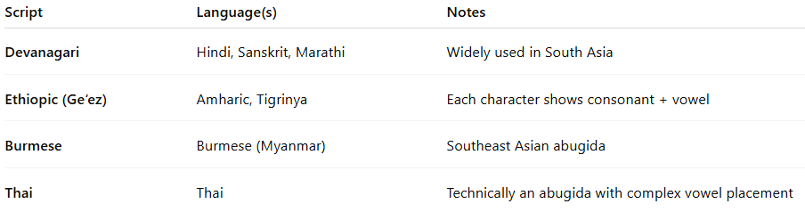

Script | Language(s) | Notes
Devanagari | Hindi, Sanskrit, Marathi | Widely used in South Asia
Ethiopic (Ge‘ez) | Amharic, Tigrinya | Each character shows consonant + vowel
Burmese | Burmese (Myanmar) | Southeast Asian abugida
Thai | Thai | Technically an abugida with complex vowel placement

✅ Advantages:
# Source: AI Source: Provided by: [Data Path: Persons Table -> ID Column: 1, Name_En Column: Motasem Essam] -> From: [Chatgpt (GPT-4-turbo)] on [7/21/2025]
- Compact and efficient for languages with predictable consonant-vowel patterns
- Easier to learn than pure syllabaries (fewer basic shapes)
- Often well-matched to the phonology of the languages they represent

⚠️ Challenges:
# Source: AI Source: Provided by: [Data Path: Persons Table -> ID Column: 1, Name_En Column: Motasem Essam] -> From: [Chatgpt (GPT-4-turbo)] on [7/21/2025]
- Complex appearance due to combining characters
- Vowel placement can be visually confusing (sometimes before/after/around the consonant)
- Can be difficult for non-native learners

🔍 Comparison Table:
# Source: AI Source: Provided by: [Data Path: Persons Table -> ID Column: 1, Name_En Column: Motasem Essam] -> From: [Chatgpt (GPT-4-turbo)] on [7/21/2025]
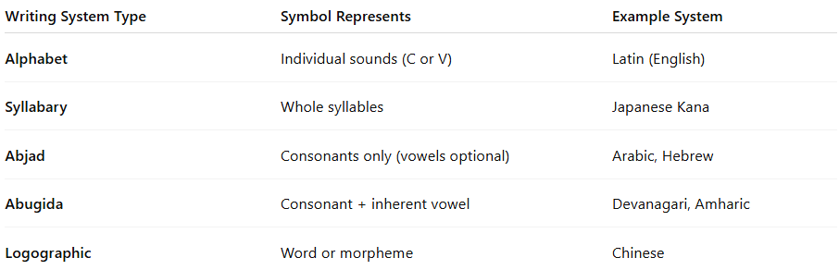

Writing System Type | Symbol Represents | Example System
Alphabet | Individual sounds (C or V) | Latin (English)
Syllabary | Whole syllables | Japanese Kana
Abjad | Consonants only (vowels optional) | Arabic, Hebrew
Abugida | Consonant + inherent vowel | Devanagari, Amharic
Logographic | Word or morpheme | Chinese

what is difference between Abugida vs Abjad
# Source: AI Source: Provided by: [Data Path: Persons Table -> ID Column: 1, Name_En Column: Motasem Essam] -> From: [Chatgpt (GPT-4-turbo)] on [7/21/2025]
Great question! Understanding the difference between an abugida and an abjad is key to grasping how different writing systems work. Here’s a clear breakdown:

🔍 Abugida vs. Abjad: Key Differences
# Source: AI Source: Provided by: [Data Path: Persons Table -> ID Column: 1, Name_En Column: Motasem Essam] -> From: [Chatgpt (GPT-4-turbo)] on [7/21/2025]
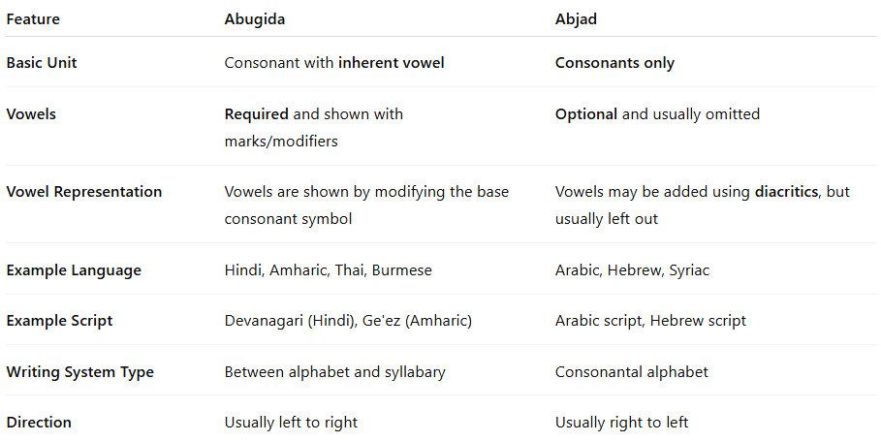

Feature | Abugida | Abjad
Basic Unit | Consonant with inherent vowel | Consonants only
Vowels | Required and shown with marks/modifiers | Optional and usually omitted
Vowel Representation | Vowels are shown by modifying the base consonant symbol | Vowels may be added using diacritics, but usually left out
Example Language | Hindi, Amharic, Thai, Burmese | Arabic, Hebrew, Syriac
Example Script | Devanagari (Hindi), Ge'ez (Amharic) | Arabic script, Hebrew script
Writing System Type | Between alphabet and syllabary | Consonantal alphabet
Direction | Usually left to right | Usually right to left

✅ Abugida Example (Devanagari - Hindi)
# Source: AI Source: Provided by: [Data Path: Persons Table -> ID Column: 1, Name_En Column: Motasem Essam] -> From: [Chatgpt (GPT-4-turbo)] on [7/21/2025]
- क = "ka" (consonant + inherent vowel "a")
- कि = "ki" (same consonant + vowel "i")
- क् = "k" (no vowel, vowel suppressed)
➤ Vowels are built into the consonants but can be modified.

✅ Abjad Example (Arabic)
# Source: AI Source: Provided by: [Data Path: Persons Table -> ID Column: 1, Name_En Column: Motasem Essam] -> From: [Chatgpt (GPT-4-turbo)] on [7/21/2025]
- كتب = "ktb" (could mean kataba, kutiba, kitāb, etc.)
- Vowels must be guessed from context unless added with diacritics:
  - كَتَبَ = kataba (he wrote)
  - كُتِبَ = kutiba (it was written)
➤ Vowels are not required and usually left out in normal writing.

🎓 Simple Analogy:
# Source: AI Source: Provided by: [Data Path: Persons Table -> ID Column: 1, Name_En Column: Motasem Essam] -> From: [Chatgpt (GPT-4-turbo)] on [7/21/2025]
- Abjad: Only consonants are written; readers fill in the vowels.
👉 Like writing “ktb” and knowing it means “kitab” (book) or “kataba” (he wrote).
- Abugida: Consonants are written with vowels by default; vowels are part of the system.
👉 Like writing “ka,” “ki,” “ku” as modified forms of “k.”

📝 Summary:
# Source: AI Source: Provided by: [Data Path: Persons Table -> ID Column: 1, Name_En Column: Motasem Essam] -> From: [Chatgpt (GPT-4-turbo)] on [7/21/2025]
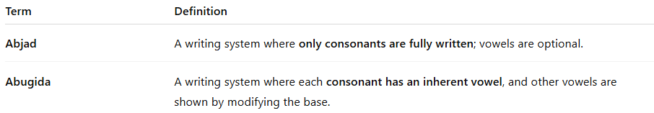

Term | Definition
Abjad | A writing system where only consonants are fully written; vowels are optional.
Abugida | A writing system where each consonant has an inherent vowel, and other vowels are shown by modifying the base.

what is difference between Abugida vs Syllabic
# Source: AI Source: Provided by: [Data Path: Persons Table -> ID Column: 1, Name_En Column: Motasem Essam] -> From: [Chatgpt (GPT-4-turbo)] on [7/21/2025]
Great question! While abugida and syllabic writing systems may look similar because they both involve syllable-like units, they work very differently under the surface.

🔍 Abugida vs. Syllabic Writing Systems: Key Differences
# Source: AI Source: Provided by: [Data Path: Persons Table -> ID Column: 1, Name_En Column: Motasem Essam] -> From: [Chatgpt (GPT-4-turbo)] on [7/21/2025]
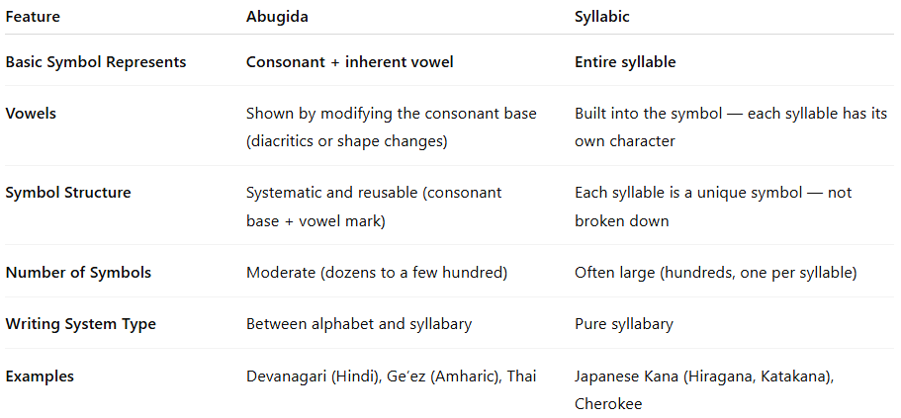

Feature | Abugida | Syllabic
Basic Symbol Represents | Consonant + inherent vowel | Entire syllable
Vowels | Shown by modifying the consonant base (diacritics or shape changes) | Built into the symbol — each syllable has its own character
Symbol Structure | Systematic and reusable (consonant base + vowel mark) | Each syllable is a unique symbol — not broken down
Number of Symbols | Moderate (dozens to a few hundred) | Often large (hundreds, one per syllable)
Writing System Type | Between alphabet and syllabary | Pure syllabary
Examples | Devanagari (Hindi), Ge’ez (Amharic), Thai | Japanese Kana (Hiragana, Katakana), Cherokee

✅ Abugida Example (Hindi - Devanagari)
# Source: AI Source: Provided by: [Data Path: Persons Table -> ID Column: 1, Name_En Column: Motasem Essam] -> From: [Chatgpt (GPT-4-turbo)] on [7/21/2025]
- क = "ka" (base consonant क + inherent vowel "a")
- कि = "ki" (क with vowel mark for "i")
- कु = "ku" (क with vowel mark for "u")
🔹 One base consonant symbol + small vowel variations
🔹 Systematic and efficient

✅ Syllabic Example (Japanese - Hiragana)
# Source: AI Source: Provided by: [Data Path: Persons Table -> ID Column: 1, Name_En Column: Motasem Essam] -> From: [Chatgpt (GPT-4-turbo)] on [7/21/2025]
- か = "ka"
- き = "ki"
- く = "ku"
🔹 Each symbol is independent
🔹 No shared "k" symbol — “ka,” “ki,” and “ku” are separate characters

🧠 Analogy:
# Source: AI Source: Provided by: [Data Path: Persons Table -> ID Column: 1, Name_En Column: Motasem Essam] -> From: [Chatgpt (GPT-4-turbo)] on [7/21/2025]
- Abugida: Like building syllables from lego pieces — same consonant base with different vowel parts.
- Syllabary: Like pre-made blocks — each syllable is a fully formed, unique block.

📝 Summary:
# Source: AI Source: Provided by: [Data Path: Persons Table -> ID Column: 1, Name_En Column: Motasem Essam] -> From: [Chatgpt (GPT-4-turbo)] on [7/21/2025]
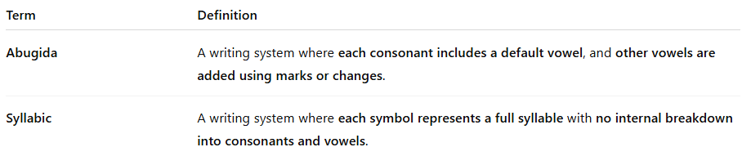

Term | Definition
Abugida | A writing system where each consonant includes a default vowel, and other vowels are added using marks or changes.
Syllabic | A writing system where each symbol represents a full syllable with no internal breakdown into consonants and vowels.

✅ Summary:
# Source: AI Source: Provided by: [Data Path: Persons Table -> ID Column: 1, Name_En Column: Motasem Essam] -> From: [Chatgpt (GPT-4-turbo)] on [7/21/2025]
An abugida is a writing system where symbols stand for consonants with an inherent vowel, and other vowels are added using marks or modifications. It’s a balance between alphabetic and syllabic systems.

